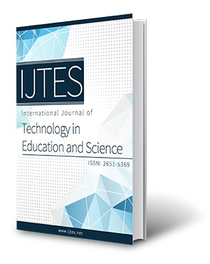  www.ijtes.net | Enhancing Visual Literacy and Performance through Motion Graphics in Learners  Kailash Pem  Open University of Mauritius, Mauritius
To cite this article:

Pem, K. (2022). Enhancing visual literacy and performance through motion graphics in learners. International Journal of Technology in Education and Science (IJTES), 6(2), 347-372. https://doi.org/10.46328/ijtes.376

The International Journal of Technology in Education and Science (IJTES) is a peer-reviewed scholarly online journal. This article may be used for research, teaching, and private study purposes. Authors alone are responsible for the contents of their articles. The journal owns the copyright of the articles. The publisher shall not be liable for any loss, actions, claims, proceedings, demand, or costs or damages whatsoever or howsoever caused arising directly or indirectly in connection with or arising out of the use of the research material. All authors are requested to disclose any actual or potential conflict of interest including any financial, personal or other relationships with other people or organizations regarding the submitted work.

This work is licensed under a Creative Commons Attribution-NonCommercial-ShareAlike 4.0 International License.

Enhancing Visual Literacy and Performance through Motion Graphics in Learners

Kailash Pem

Article Info |  | Abstract
Article History  Received:  13 November 2021  Accepted:  11 March 2022 |  | The study sought to determine the effect of animated motion sequences on visual literacy for Grade 8 biology learners. This study included a series of case studies to probe deeply into the visual literacy skills. Following the completion of 15 animations created with Flash Mx software package guided by the ACE model, pretests were administered at the start of the study followed by the animations and then the posttests and summative tests. The tests addressed the seven visual literacy indicators namely identify, find, understand, evaluate, use, create and extract indicators. It was observed that students from low, average and high performing schools scored improved marks. Regarding the seven visual literacy indicators, an increase in the mean marks and mean ranks through the Wilcoxon matched-pairs test was noted for the indicators. Gender-wise it was observed that girls had a higher mean percentage than for boys except for the “essence” and “understand” indicators.
Keywords
Visual literacy indicators
Animations
Motion graphics
Visual

Introduction

The present research work investigated the impact of the intensive use of tailored animated visuals on the visual literacy skills through the 7 visual indicators in Grade 8 biology learners. Only seven competencies were taken onboard from a non-exhaustive list as per the age groups. There is a dearth of research work examining the development of visual literacy in this age group (12\13 years) in the educational landscape. The research aim was to develop visual literacy skills through motion graphics and subsequently assessing the development of the skills through the performance of the learners. Moreover, literature mentioned mostly about animations that were taken from open educational resources as compared to the present work where the animated visuals were created by the teacher-researcher as per set protocol and as per the local context and content (Admiraal, 2022). Downloaded animations were not in line with the aims and objectives of the particular lessons and thus not appropriate. Another issue is the poor quality of the educational materials as posited by Tang et al. (2020) which does not add value to the lesson. A further contribution made by the current study was that students were taught visual literacy skills as there is limited research in this area as per Oliver-Hoyo & Babilonia-Rosa (2017).

The focus of the study was on Grade 8 biology learners and it is good to point out that an early intervention in Grade 8 can impact on the trajectory the students will take in upper classes. Another reason why Grade 8 students were chosen as the most suitable unit of analysis was because Grade 7 students were still adapting to the transition from primary to secondary schooling and still forming their learning preferences. Regarding Grade 9 students, they had already opted for Science or Economics sides. As for Grade 10 to 13, the very low population size would not have allowed conducting the research and also at times biology is not offered due to lack of students.

On the other hand, Subrun. L & Subrun. V (2015), claimed that despite many changes in the curriculum, many schools in Mauritius have not integrated technological tools that have been been put at their disposal in the teaching and learning process. One study in Germany stated that only 24% of educators make use of digital tools like laptops, computers and other devices even if an array of digital visual resources is available (Dittmar and Eilks, 2019). Educational technologies are crucial in the transformation process to meet the 21st century demands of the society as affirmed by Salas-Rueda (2020). As per Auckbur (2012), lots of teachers are following the traditional teaching model where there is more of print based and white/black board delivery with a minimum use of ICT. It was also established that science teaching was too teacher-oriented with around 93.8% of educators adopting the main teaching method through the textbooks. It was also found that 61.9% of the respondents disagree with teachers who provide only notes. Surveys also provided information with 35% of the students who found the teaching method stated above as boring (Maulloo and Naugah, 2017). It is recommended that more active learning approaches to science teaching should be employed and greater opportunities must be provided to use computer software and multimedia to promote independent learning among students (MRC, 2004). Moreover, the syllabi for Grade 7 to 9 clearly specify the intensive use of ICT and visualisations in the delivery of biology lessons (MIE, 2011).

Learning through Motion Graphics

Hegarty (2014) defines an animation as a combination of static images presented at high speed that changes its structure over time and which triggers the perception of a continuous change by viewers. An animation is based on learning by viewing approach and is used to show changes in a process in science education over time. Animations are ideal digital tools with visual contents that improve and add value to the learning process and raise competencies in students (Ugur, 2020). Abed (2019) on the other hand, recommends the integration of technology including multimedia resources to enhance the teaching and learning environment. To enhance the effectiveness of an animation, the information is presented slowly and incrementally in smaller chunks to students thus providing them with ample time to digest and assimilate the features that are obvious to the designer but not to the students. Boucheix and Forestier (2017) reported that animations where information is presented in small sections are more efficient than static images. This is because there is a flow in comprehension process since the previous information is a precursor for processing in the highly limited working memory, linking to the new information and eventually content understanding. Animation elicits the viewer's automatic ability of the visual system to directly encode them into both visual and verbal form, while static image requires an additional effort to form mental images by connecting and integrating discretely presented information.

Evidence was found for the compensatory effects of animations over static pictures (Münzer, 2015). Thus, the importance of animations is to assist in describing abstract concepts (Mnguni & Moyo, 2021) that are difficult to elucidate through verbal and textual instructions only. Findings showed that there is a significant growth on students’ academic achievement in biology and thus computer animation is recommended as a means of teaching biology (Prinsloo et al., 2018). Consequently, the affective domains like self-esteem and attitude were also positively affected with enhanced delight and the drive to use multimedia (Koseoglu & Efendioglu, 2015).

Visual Literacy

In its broadest term, literacy means someone with adequate and proper knowledge together with particular skills in domains that of reading, writing, understanding and composing (Hazar and Keser, 2021). The definition has been deepened and incorporates a set of progressive skills namely “researching, discussing, listening, viewing media, communicating with words and with the body, connecting illustrations and text, role playing to create meaning through stories” (Ontario Ministry of Education, 2019). Kellner (1998) coined the term multiple literacies, also known as ‘multiliteracies’ an umbrella term that subsumes print literacy, visual literacy, aural literacy, media literacy, computer literacy, cultural literacy, social literacy, digital literacy and eco-literacy. Ryan (2020) referred to a wide range of aspects like communication, comprehension, critical analysis, and skills to understand digital technologies, video (visual images), television (digital images), and new media (screens) all falling under multiliteracies. The different literacies mentioned are important to ‘read’ the world using the various skills and make sense of information. People from modern societies should possess the above-mentioned literacies to be able to construct knowledge from multiple and varied sources of information (Seel, 2012).

Sinatra (1986) argued that visual literacy is a primary skill that precedes other literacies like verbal skills during the course of human development. Like for instance, at the age of around eight months, babies are able to memorise and distinguish their parents from other people. Children at the tender age of one year can read graphics and they know that a representation of an orange equates to a real orange. At three, they can produce their own drawings for example showing emotions like happiness. They can even use visual symbols like rectangles and circles to draw a car. A growing body of research has revealed countless variations on the definition of visual literacy (see Table 1).

Table 1. Timeline for Visual Literacies
Year | Author | Viewing competencies
1969 | (Debes, 1969) | - developing visual competencies  - seeing and integrating other sensory experiences  - discriminate visible object  - interpret visible objects  -comprehend the masterworks of visual communication  - enjoy masterworks of visual communication
1983 | (Horton, 1983) | - understand images  - read images  - use images  - write images  - think in terms of images  - learn in terms of images
1984 | (Robinson, 1984) | - process visual messages  - perceive visual messages  - understand visual messages  - interpret visual messages  - analyze visual messages  - evaluate visual massages
1986 | (Sinatra, 1986) | - promote understanding  - promote retention  - promote recall  - reconstruction of past visual experience  - compare between past and incoming visual messages  -create meaning from past and incoming visual messages
1993 | International Visual literacy Association (IVLA) (Pettersson, 1993) | - Visual competency accompanied by aural & verbal abilities  - interpret visuals  - compose\produce messages from visuals  -encode visual image i.e. convert pictural to verbal mode  - decode visual image (understand a visual language)  - evaluate visual information  - detect visual information from the visual environment  - produce messages
1994 | (Bristor & Drake, 1994) | - Understand visual messages  - interpret visual messages  - evaluate visual messages
1996 | (Braden, 1996) | - understand images  - use images  - create images  - think in terms of images  - learn with images  - express in terms of images
1997 | (Christopherson, 1997) | - Interpret visual messages  - understand visual messages  - appreciate visual messages  - communicate visual messages  - produce visual messages  - use visual thinking for problem-solving
1999 | (Rezabek, 1999) | - interpret images  - create messages
2001 | (Brill et al., 2001) | - interpret visual messages  - compose from visual  - discriminate from visible objects  - make sense of visible objects  -create static and dynamic visible objects  - understand visual messages of others  - appreciate visuals of others  - invoke images in the mind’s eye  - categorize visuals  - derive meanings from visuals  - generate still and moving visuals
2002 | (Burmark, 2002) | - interpret visual messages  - understand visual messages  - appreciate meanings of visual messages  - communicate visual messages  - produce visual messages  - use visuals for problem-solving  - applying principles of visual design  - analyzing visual messages
2006 | (Johnson, 2006) | - see messages hidden in images  - comprehend messages hidden in images  - generate visual prompts  - adapt visual prompts  - employ visual prompts
2007 | (Robertson, 2007) | - read visual messages  - translate from visual to verbal mode
2008 | (Metros, 2008) | - decode visual messages  - encode visual messages  - infer from visual messages  - compose meaningful visual  - communicate meaningful visual to the audience
2011 | (ACRL, 2011) | - find images and visual media  - interpret images and visual media  - evaluate images and visual media  - use images and visual media  - create images and visual media  - consumer of visual media  - understand visual materials  - analyze visual materials

Smolkin and Donovan (2004) observed that graphics were used in the classrooms by just pointing to them without venturing through and across them. Focus was mostly on reading and writing (Yeh & Lohr, 2010). This promotes only low order visual literacy skills and Milner-Bolotin and Nashon (2012) concurred that the majority of university biology students were not given the opportunity to build on their visual literacy skills in lower classes which are important to make the learning environment in science classes more productive. Mnguni (2019b) agreed that lack of visual literacy skills such as visualization skills contributed in the low performance in science subjects.

High order visual literacy can be achieved through science visual literacy where teachers can spare some time (Michael and Matthews, 2015) to teach about science graphics on its purpose and how students should examine visual grammars in graphics effectively (McTigue et al., 2011) so that learners can construct meaning from the visuals. The five main steps before understanding a concept are seeing, examining and learning, interpretation, communication and comprehension. A visually literate person will use all the five steps unconsciously. So training is important where students are taught how, where and what to “see”. The way forward is to expose students to a variety of interesting visuals and hands-on activities for deep visualization (Palmer & Matthews, 2015). The study by Mangen and Velay (2011) is known for advocating that writing and drawing by hand promote learning since there is direct interaction between the motor action and the visual cortex of the brain receiving information. So viewing together with other sensory experiences like drawing, writing and doing is a way to teach science visual literacy (Bell, 2013).

Being visually illiterate today would be a disadvantage to most of us because we are living in a world where we are constantly bombarded with visuals, whether it is through bill-boards on the high way, media, smart-phones, internet, Facebook, advertisements and YouTube (White, 2012). The usual and most common form of educational settings comprise, of learners who are mostly exposed to verbal instructions thus not trained to extract meaning from visual aids (Coleman, 2010). This may be attributed to the fact that many educators make use of the verbal form of communication in science classes with little usage of visuals. As a result, teachers need to learn to teach visually by developing pedagogical-visual-content-knowledge. This will allow them to identify and select effective visuals for a particular class as per the level and context in which students are evolving (Schroeder et al., 2011).

Little, Felten and Barry (2010) argued that students are not taught high order visual literacy skills that are how to read, create, analyse and interpret visual messages. More emphasis is laid on texts from books than visual information (Weiss et al., 2003). Thus, it is important to instill high order visual literacy skills in students (Tillmann, 2012). An example is visual thinking (Offerdahl et al., 2017) in which the approach is to generate and organize mental images in a meaningful way (Estrada et al., 2015) by considering the contours, colors and other visual conventions. The skill is essential where students can critically interpret and communicate information through science experiences. Another example is through visualization skills which comprise of 3 phases, namely, internalization, conceptualization, and externalization (Mnguni, 2014) that can contribute in building up visual literacy in biology students.

Very limited numbers of research work have been conducted on measuring visual literacy skills in students (Arslan and Nalinci, 2014). Acquaintance with skills related to visual literacy is very important to be able to discern meaning (Brumberger, 2011) because subjects like Sciences make heavy use of images in the learning process. The American Association of School and Research Libraries (ACRL) has issued in 2011, a list of Visual Literacy Competency Standards that steer a person in his quest for visual literacy skills. The Competency Standards can be used across many disciplines. Currently, in all scientific fields, students are employing visuals for academic purposes but without following any benchmark or reference point. These 21st century competencies can be acquired through training as asserted by Gocen and Duman (2021) in the form of visual literacy education. Lastly, Mnguni (2019a) asserts that visual literacy is specific to a subject as well as the context and thus will be different for other disciplines. Like for instance if a learner is good at interpreting visuals in say mathematics, which does not mean that he\she can do same for science.

Method
Research Design

The study was an explanatory multiple case study that incorporated a series of causal case studies (Creswell and Clark, 2011) to probe more deeply into the real-life experience (Yin and Davis, 2007) of human subjects about visual stimulation. Explanatory research also known as causal research was thus opted because not enough in-depth research (Yin, 1984) has been conducted on visual literacy in biology at Grade 8 level thus providing more details on visual literacy. Such in-depth research helped to understand the problem more efficiently and even laid out the foundation as the building blocks of future studies on visual literacy. Validity and reliability increase transparency, and decrease opportunities to insert researcher bias in qualitative research (Singh, 2014).The multiple case study was chosen as the research methodology because it gave more robustness and heterogeneity (Linda, 1997) to this study hence the possibility to generalize in other similar scenarios outside this study. The design was replicated in six randomly chosen schools in 10 different grade 8 classes (10 cases) with a total of 311 students thus providing additional depth of information as opposed to a single case study hence increasing the validity of the research findings (Yin, 2009). Miles and Huberman (2014) attested that an investigation with above ten cases can generate too many permutations to account for. The six schools were categorized into three different groups, namely under-performing, average performing and high performing mixed-ability schools

Moreover, the heterogeneity factor was present that enhanced generalization. All these increased the external validity of the research project. Since all the students in this study were from Grade 8 classes following the same syllabus, this meant that the criterion of homogeneity was also satisfied and augmented internal validity and facilitated replication. Regarding the dependent variable i.e. visual literacy in the current research, it was found that it was measurable through formative and summative assessments which consisted of questions based on the seven visual literacy standards set for the Grade 8 biology students. This catered for the construct validity (Keating and Krumholz, 1999). Finally, the last test was on reliability i.e. the same procedures were adopted for all schools as per set protocol on how to use the tailored animations. A logic model more precisely a theory of action (Patton, 2002) in the form of a road map with the teaching strategies, was developed that stipulated a complex chain of events over time across the three semesters. The teachers followed a protocol that guided them in data collection phase at each site. Twycross and Shields (2004) claimed that consistent results that are obtained in identical situations make a study reliable. In the present study, all the students were from grade 8, biology students following the same syllabus and same customized animations.

Designing and Employing the Visual – Assisted – Materials

The resource materials were developed by following the subsequent five steps (Hoban and Nielsen, 2010) chronologically. The first one was carrying research work on the intended animated graphics and preparing research notes which included the information on the texts, images and other visual grammars, then from the research notes preparing for storyboards followed by creating a model for each animation by sketching on paper from scratch. The drawings were then converted into the final digital motion graphics by using the Macromedia Flash Mx 2004 package. The developed animated visuals were in line with the new National Curriculum Framework (Ministry of Education, 2009) and the students’ abilities. The ACE model was followed for the design and production of the resources (Karen et al., 2010) with the learners’ prior knowledge in mind as per the syllabus that they have covered in Grade 7. The steps followed as per the ACE model culminated into a set of 15 animations (see Table 2) spread across the three terms with an average duration between 2 to 3 minutes (Hoban and Nielsen, 2012). The dynamic visualization comprised of an optimal amount of information to prevent transient information effect which could weaken the superiority of the motion graphics as per Boucheix and Forestier (2017). Moreover, accompanying narration from the educators stretched the lesson to a maximum of around 20 minutes. It is known that it is during the first 20 minutes that students have the highest concentration span (Fleming, 2009).

Table 2. Animations Used Across the Three Terms
 | TERM 1 | TERM 2 | TERM 3
Topic | Energy and matter | Health and safety  (1st part) | Health and safety (2nd part)
Tailored Animations | - Photosynthesis | - Reproduction | 13. Infectious disease
 | - Test for starch | - Male reproductive system | 14. HIV transmission
 | - Energy flow in terrestrial ecosystem | - Female reproductive system | 15. Other modes of HIV transmission
 | - Vein | - Fertilization and Implantation
 | - Large surface area | - Menstrual cycle
 | - Chlorophyll
 | - Stomata

Smolkin and Donovan (2004) talked about teachers in general who just point to visuals without carrying deep viewing i.e. studying the frames closely and in depth so far the seven visual literacy indicators are concerned. The teaching and learning mode is mostly on reading from books and writing notes in copybooks as per Yeh and Lohr (2010). So the team was instructed to talk about motion graphics used in biology. McTigue et al. (2011) advised to guide students on how to deeply examine graphics in a meaningful way allowing students to
- ‘see ahead’- predicting the next idea or event
- ‘see behind’- connecting all ideas from previous topics
- ‘see above’ - understanding the concept
- ‘see below’ - a deep understanding of the content
- ‘see beside’ - creating ties between related concepts
- ‘see beyond’ - applying the ideas in other context

Other authors such as Estrada et al. (2015) proposed to teach students high order visual literacy skills through visual thinking by creating mental images. Furthermore, one study has shown that the learning gains increase if an animation is coupled with narration because it provides all relevant and concise information to the listeners (de Koning et al., 2010). Besides, through narration cognitive load on the visual channel is reduced hence permitting the students to effectively process the visual information and consequently constructing an accurate mental pictorial model of the object. The effectiveness of the working memory is shown to increase when the animation is accompanied by spoken explanation because of low demand on the working memory (Paas et al., 2003).

Assessment of Visual Literacy Indicators

The formative tests were thus spread over the second and third term. The continuous assessments were testing the seven visual indicators namely identify, find, understand, evaluate, use, create, and essence as per (Hattwig et al., 2013). At the end of the year summative tests were administered with all the visual indicators mentioned.

Results and Discussion
Research Question 1

The performance in the seven literacy indicators was studied and compared before and after using the animated visuals. This part of the study answered the following research question with its set hypothesis.

RQ 1: Does the effective use of customised visual-pedagogy enhance visual literacy in students?
Ho: Effective use of customised visual-pedagogy does not enhance visual literacy in students.
H1: Effective use of customised visual-pedagogy enhances visual literacy in students.

Test for Normality on the Visual Literacy Indicators

Out of the total of 311 students, above 80 % of the students participated in the pre and posttests by answering all the questions. The significance for both tests (K-S and (S-W) for the seven visual literacy indicators was 0.000 (see Table 3) which was below 0.05. Thus, the tests were significant and hence the data were not normal. So, non-parametric tests were applied to the data.

Table 3. Tests of Normality for the Seven Indicators
 | Kolmogorov-Smirnov |  |  | Shapiro-Wilk
 | Statistic | df | Sig. | Statistic | df | Sig.
IdentifyPreOn2mks | .375 | 216 | .000 | .698 | 216 | .000
IdentifyPostOn2mks | .465 | 216 | .000 | .550 | 216 | .000
FindPreOn9mks | .210 | 216 | .000 | .850 | 216 | .000
FindPostOn9mks | .113 | 216 | .000 | .955 | 216 | .000
UnderstandPreOn8mks | .200 | 216 | .000 | .921 | 216 | .000
UnderstandPostOn8mks | .157 | 216 | .000 | .932 | 216 | .000
EvaluatePreOn5mks | .258 | 216 | .000 | .867 | 216 | .000
EvaluatePostOn5mks | .189 | 216 | .000 | .882 | 216 | .000
UsePreOn11mks | .165 | 216 | .000 | .929 | 216 | .000
UsePostOn11mks | .180 | 216 | .000 | .878 | 216 | .000
EssencePreOn3mks | .255 | 216 | .000 | .844 | 216 | .000
EssencePostOn3mks | .229 | 216 | .000 | .826 | 216 | .000
CreatePreOn7mks | .214 | 216 | .000 | .873 | 216 | .000
CreatePostOn7mks | .135 | 216 | .000 | .936 | 216 | .000
TotalSummativeOn36mks | .102 | 216 | .000 | .971 | 216 | .000
TotalpreOn45 | .106 | 216 | .000 | .976 | 216 | .001
TotalpostOn45 | .082 | 216 | .001 | .982 | 216 | .008
Comparative Descriptive Statistics on the Visual Literacy Indicators

An increase in the mean marks was noted for all the visual literacy indicators during the formative posttest as an evaluation instrument (see Table 4). The highest increase was for the “find” indicator and the lowest increase was for the “identify” indicator. The total pre\posttest has yielded a drastic increase by above 100%.

Table 4. Descriptive Statistics on Formative Tests
Visual literacy indicators\marks | Test type | Mean | Mode
Identify \ 2 | Pre | 1.49 | 2
 | Post | 1.71 | 2
Find \ 9 | Pre | 1.38 | 0
 | Post | 5.15 | 6
Understand \ 8 | Pre | 2.60 | 2
 | Post | 4.99 | 6
Evaluate \ 5 | Pre | 1.64 | 1
 | Post | 3.36 | 5
Use \ 11 | Pre | 3.22 | 1
 | Post | 8.04 | 11
Essence \ 3 | Pre | 1.04 | 1
 | Post | 2.10 | 2
Create \ 7 | Pre | 1.49 | 0
 | Post | 4.26 | 5
Total \ 45 | Pre | 13.09 | 12
 | Post | 30.27 | 27

The result showed that with the use of the tailored animations, there has been growth in the visual literacy indicators indicating that students progressed towards being visually literate students. One study by Kelley (2021) mentioned that the visuals should be consistent in the sense that whatever is included in the animation should be in line with the syllabus and teacher narratives to avoid confusions. It was also observed that the most common scores earned by participants were the maximum marks for each of the indicators. Like for instance, “identify, evaluate, use” indicators where the mode was the maximum marks i.e. 2, 5 and 11 marks respectively.

It was noted in the bar chart (see Figure 2) that all the three types of schools had registered an improvement in the visual literacy indicators for the pre\posttest prior to the use of the customized animations. The improvement in visual literacy indicators varied between the types of school. For example, for the “identify” visual literacy indicator, the difference between the pre\posttests was low as compared to the rest of the indicators. This was seen in all the three types of school. It meant that students were quite at ease before and after the pre\posttest to “identifying” from a set of complex graphics the one that is not involved in the transmission of the AIDS virus and the process of photosynthesis. As for the rest of the indicators, they have registered an increase in mean where the tailored animated visuals have contributed in “finding” mentally the different parts of the male reproductive system and then slotting them in the outline. They were also good in finding the organs like ovary and fallopian tube in the female reproductive system and also the route where the egg travels. The “understand” indicator as well showed an improvement. Students were able to describe and explain the concept of perpetuating a species as well as examining and anticipating for what will happen next in the event. They were also able to write down the correct sequence of events starting from deposition of sperm cells in the vagina until an embryo is implanted developing into a foetus. All these cognitive abilities demonstrated conceptual understanding and strengthen their literacy skills (Susanto et al., 2021).

Students accomplished the task of translating the illustration provided on infectious disease into words. They explained the “How” aspect so far transmission of AIDS was concerned. Another question pertaining to the “understand” indicator was by translating texts into labeled and annotated diagrams in the correct order. Bulunuz (2019) reported that annotated illustrations are a good means to visually describe the learners’ level of understanding and approach of thinking especially in strong visual learners. The “evaluate” indicator was assessed through a graph where students had to weigh up the consequences of implantation at the right or wrong time in relation to the thickness of the uterine lining. Another question was where students had to evaluate the order in which shedding of the uterine lining occurs. They also had the task to estimate for the best place for the process of fertilization to take place with reference to the release of an egg and deposition of sperm cells. The last task was to explain how, when and why tattooing can be a risky activity with respect to the transmission of an infectious disease. The next indicator that was assessed was the “use” component where students had to use incomplete diagrams provided to them to predict an outcome. Students were also tasked to use a side view diagram to draw and label a front view version of the diagram.

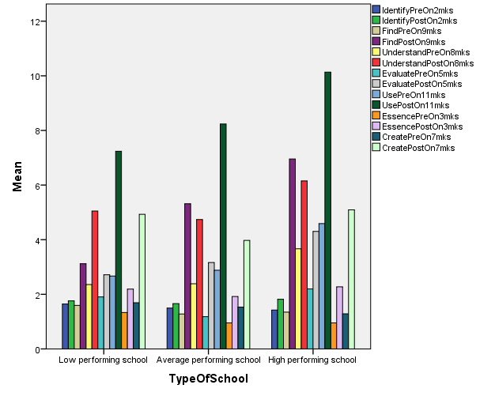
Figure 2. Mean Performance School-Wise for the 7 Indicators

Moreover, they were tasked to use a given diagram to name the systems that were displayed. The other indicator was “essence” where students had to catch the gist of the concept from a display in one line or few precise wordings. For example, learners had to study the different levels in a family tree diagram before stating in few words on what is being demonstrated. Students had to use a one word answer to describe the act of fusion between an egg and a sperm cell and also to write a title from a given illustration. The last indicator was on “create” where students had to create a new illustration to describe an idea of infectious disease. They also had the task of creating a flip-book by cutting through diagrams and placing them in the right order which summarized the topic on health and disease.

Thus, overall, there was enough evidence that the tailored animated visuals contributed immensely in enhancing visual literacy in the learners through the 7 visual literacy indicators. These outside educational materials had a positive outcome in the conceptual understanding and improving the scores (Skoumios and Skoumpourdi, 2021). This also confirmed that teachers can successfully create their own multimedia teaching resources with the bid to make the lessons more engaging and interesting provided that the animations meet the learning needs. The teachers correctly followed the instruction like for example to carry out deep viewing with the students and analyzing the animations frame-wise with all the relevant details. They were also briefed to lay out the aims of the concepts as per the syllabus to the students so that students were aware of what to pay attention with respect to all the visual grammars used in the animated graphics. So all these aspect combined contributed to the good marks earned by the students. However, Dries et al. (2016) agreed that motion graphics are being used in biology classes but without teaching learners the visual literacy skills like visualization skills necessary for efficient learning. Yilmaz and Argun (2018) concurred that visualization is a powerful tool that lessen the complexity of a concept by engaging the learner in multidimensional thinking. Moreover, visualization process is said to develop deductive and inductive reasoning by establishing connections between unknown ideas consequently developing understanding gradually.

The total of the pre\posttests also registered an increase in performance with an increase in mean mark by 13.81, 17.29, 21.26 for the low, average and high performing schools respectively (see Figure 3).

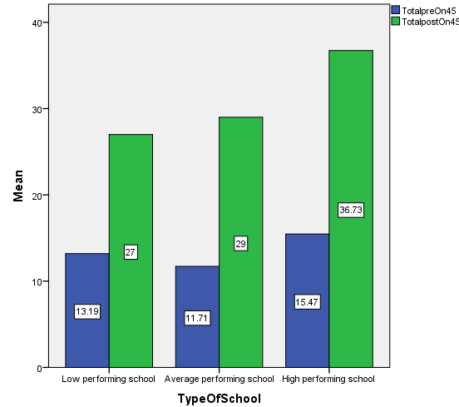
Figure 3. Mean Performance for the Different Types of School

Results for gender-wise comparison showed that girls out-performed boys except for indicators like “essence” with a difference of 0.28% and “understand” with a mean difference of 0.8% (see Figure 4). A study by Wood et al. (2021) referred to girls being more comfortable with educational technology as compared to males who were better towards reflecting on educational technology. However more in-depth research work is needed on factors contributing to the gender-based differences.
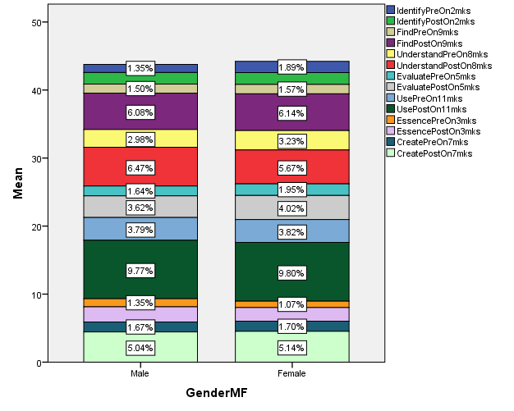
Figure 4. Gender-Wise Comparison for the Mean Marks

When the total of all the indicators was combined, an increase in mean percentage was observed for both males and females. Like for instance, it was observed that the mean difference between the total of the pre and posttests for males was 21.14% and that for females was slightly lower with 19.78% (see Figure 5). All the figures confirmed that adequate and proper training of the students during the 3 semesters was an important factor that contributed to enhance visual literacy in both genders.

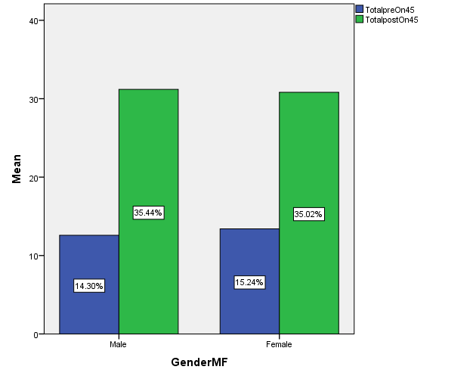
Figure 5. Gender-Wise Comparison for the Total Mean Marks
Concerning the total marks obtained for the summative test, it was noted on 267 responses, the mean score obtained was 55.13 on a total of 75 marks. The minimum mark obtained was 40 over 75 whereas the maximum earned was 75 over 75 with a modal mark of 48. So the performance was far beyond 50% even for low ability students with a minimum of 40 marks as mentioned above. Statistics presented by the Mauritius Institute of Education (Bholah, 2016) has shown that between 30 to 50% of the students at Grade 9 National exams earned less than 40 marks which is considered fail and with less than 10% obtained between 90 to 100 marks. Thus, the good performance (see Table 5) after the use of the animations was in line with research work carried by Kühl et al. (2018) which demonstrated that animated visuals improve students' knowledge of scientific phenomena.

Table 5. Descriptive Statistics for the Three Categories of Schools
 | Under performing school | Average performing school | High performing school
Number of valid participants | 62 | 142 | 63
Mean of total Summative MCQ | 49 | 54 | 64
Standard error of mean | 0.481 | 0.548 | 0.853
Minimum mark | 40 | 43 | 50
Maximum mark | 62 | 75 | 75

It was found that the mean for the Total MCQ summative test (see Figure 6), for the underperforming school demonstrated a mean of 49 marks on a total of 75 marks.

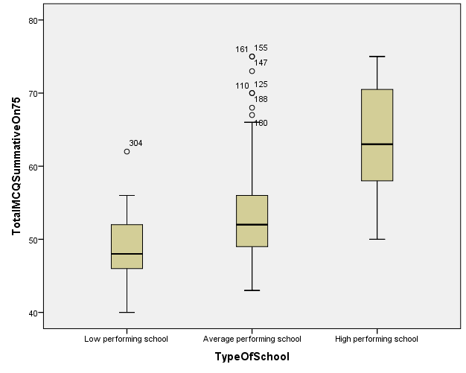
Figure 6. Distribution of Marks for the Schools

This was the lowest mean as compared to the average and high performing schools where the means were 54 and 64 marks respectively. The minimum mark for low performing schools obtained was 40 as shown by the whiskers in the table above and the maximum was 62 marks. For average performing schools, minimum mark was 43 versus 75 marks as maximum similar to high performing schools. And minimum mark was 50 for high performing schools. So low performers scored between 54% to 83%, average performers earned between 58% to 100% and high ability students bagged between 67% to 100%. This showed that all categories of schools scored above 50%. Seven outliers were noted for average performing school as opposed to one outlier for low performing schools and no outlier for the high performing school. These can be observed on the box and whisker diagram above. The relatively good performance for the low abilities may be attributed to the fact that these students were exposed to customized visuals for understanding difficult concepts. A report from the quality assurance department (MoE and HR, 2014) commented that ‘most students were able to tackle low order questions with one word or short answer questions’. Students had difficulty to attend to questions requiring descriptive answers (Ministry of Finance and Economic Development, 2017) contributing in the poor results. The report was referring to low performing students and the animated visuals contributed in scaffolding the low ability students and hence the improved performance. One paper by Affeldt and Eilks (2018) indicated that the low achievers are more interested with creative teaching approaches like visual communication instead of dealing with long textual instructions. Short information coupled with visuals is a good means to motivate learners.

As for average performers, the outliers showed good results as well. One student among the low performers scored above 60 marks. On inquiry with the concerned teachers, it was found that this student was very enthusiastic to use the customized animations as it helped to better understand the ideas. The finding was supported by Vagg et al. (2020) who claimed that multimedia engages student and helps learners to focus on the lesson making concepts lucid. These aspects are important precursor to academic achievement.

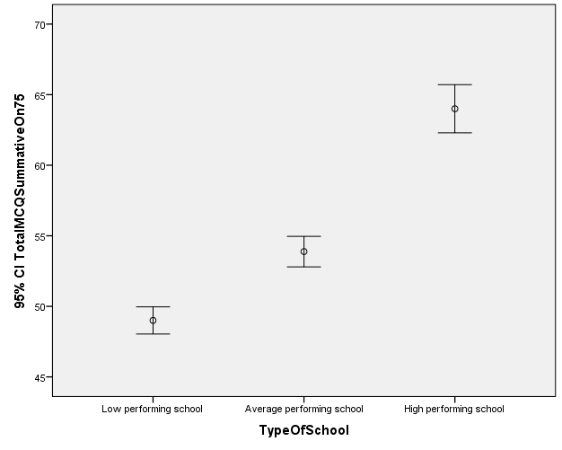
Figure 7. Error Bar Depicting the Spread from the True Mean

As for the standard error of the mean (SEM), it was noted that the true mean for low performing schools fell between 49+\-0.481, and for average-performing schools, the true mean fell between 54+\-0.548 and 64+\-0.853 for high-performing schools as can be seen graphically in the error bar figure above (see Figure 7). It was noted that the SEM was small which meant a low spread and the data are clustered around the mean. Also, the small SEM meant more reliable mean value. The error bar chart also showed that there was no overlapping between the schools. Thus the difference between the schools was significant.

Out of the 311 candidates, 90 males and 177 females participated in the summative MCQ test to assess whether the animated customized visuals helped in remembering and retaining the concepts. The mean performance for a male was 56.53 marks in opposition to 54.42 for female as displayed above (see Figure 8). Thus boys got better marks on average than girls. Box plots were used to map the data and show overall patterns and spread of response for a group. The box plot helped in visualizing the range which was the maximum i.e. 75 minus the minimum i.e. 40 resulting in 35 marks for males and 32 (75 as maximum – 43 as minimum) for females. Other characteristics that were displayed by the graph were the median performance which was 54 marks for males against 52 marks for girls. This meant that half out of the 90 males, had above 54 marks and half below and half out of the 177 girls got above 52 marks and half below. Another characteristic revealed by the box plot was that 75 % of the scores fall below the upper quartile which was 64 marks for males and 57 marks for females. As for the lower quartile, it was found that twenty-five percent of scores fell below the lower quartile which was 50 marks for males and 49 marks for females. The lower marks for females compared to males for the different quartiles showed that boys performed better after the use of the visuals. Incidentally, girls in Mauritius are reputed to perform better in exams at primary, secondary and tertiary levels (Ministry of Finance and Economic Development, 2017).

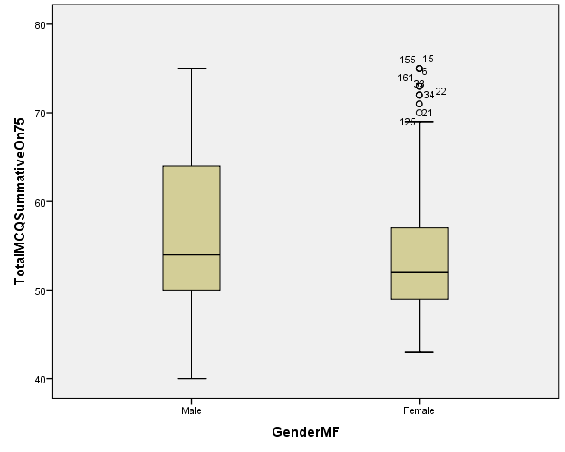
Figure 8. Distribution of Marks for Males and Females

Wilcoxon Matched-Pairs Signed Ranks Test on Pre and Posttests

The Wilcoxon Signed Tanks Test was used to compare the difference between the means of the seven visual literacy indicators through the pre\posttests prior to the use of the tailored animations. The procedure was used to compare two related samples to assess whether their population mean ranks differed.
For all the seven visual literacy indicators, it was found that the “Identify” indicator achieved the highest number of ties of 144 as compared to the “Use” indicator which scored the lowest number of ties which was 12 (Table 2). This meant that the 144 students scored the same marks for the “Identify” indicator for the pre and posttest. The same applied to the 12 students who scored the same marks on the “Use” indicator for the pre and posttest. All the rest of the indicators that is the “Find, understand, evaluate, essence and create” was between 18 and 57 as the number of ties. Two visual literacy indicators namely, the “Evaluate and Essence” indicators had the same number of ties i.e. 57. This high number that is 144 demonstrated that around 51 % of the students were already acquainted with the “Identify” indicator (see Table 6).

Table 6. Differences between Visual Indicators Ranks
Visual literacy indicators | Number of students
 | Ties | Negative ranks | Positive ranks
IdentifyPre\postOn2mks | 144 | 45 | 92
FindPre\postOn9mks | 18 | 18 | 249
UnderstandPre\postOn8mks | 26 | 33 | 241
EvaluatePre\postOn5mks | 57 | 27 | 208
UsePre\postOn11mks | 12 | 17 | 275
EssencePre\postOn3mks | 57 | 33 | 211
CreatePre\postOn7mks | 23 | 22 | 245
Totalpre\postOn45 | 0 | 1 | 218
IdentifyPre\postOn2mks | 144 | 45 | 92

This may be attributed to the fact that most of the teaching strategies in traditional or untraditional teaching focused on this visual literacy skill where students were frequently asked to recognize a structure from a list\diagram and state the name of that structure. As for the low percentages which ranged from around 6 % to 20 % where there were fewer ties in the rest of the indicators, showed that the students were not well conversant with these visual literacy skills. There is an urgent need to instill these visual literacy skills in the curriculum. For the positive ranks, i.e. where more students have scored better in the posttest than the pretest, it was found that for all the indicators, students have earned higher positive ranks than the negative one. The result showed that most students had shown improvement in the above mentioned visual literacy skills after the use of the animated sequences.

An increase in mean ranks was observed for all the seven indicators as well as the total pre\posttests (see Table 7). Like for instance a rise by 10.27, 90.43, 98.47, 46.99, 84.51, 46.63, 95.58 were registered for “Identify, find, understand, evaluate, use, essence, create” indicators respectively. The largest rise was for the “understand” indicator with an increase by 98.47 as compared to the lowest rise for “identify” indicator which was 10.27. It meant that students were already acquainted with the “Identify” indicator but not with the other indicators. Thus, the tailored visuals had an effect on improving the marks earned through the visual literacy indicators.

Table 7. Visual Indicators Mean Ranks
Visual literacy indicators | Learning modes Before Vs After | Mean Rank
Identify | Identify pretest | 62.09
 | Identify posttest | 72.38
 | Difference in mean rank for identify indicator | + 10.29
Find | Find pretest | 49.67
 | Find posttest | 140.10
 | Difference in mean rank for Find indicator | + 90.43
Understand | Understand pretest | 50.89
 | Understand posttest | 149.36
 | Difference in mean rank for Understand indicator | + 98.47
Evaluate | Evaluate pretest | 76.41
 | Evaluate posttest | 123.40
 | Difference in mean rank for Evaluate indicator | + 46.99
Use | Use pretest | 66.91
 | Use posttest | 151.42
 | Difference in mean rank for Use indicator | + 84.51
Essence | Essence pretest | 82.18
 | Essence posttest | 128.81
 | Difference in mean rank for Essence indicator | + 46.63
Create | Create pretest | 46.30
 | Create posttest | 141.88
 | Difference in mean rank for Create indicator | + 95.58
Pre\posttest Total | TotalpreOn45 | 1
 | TotalpostOn45 | 110.50
 | Difference in mean rank for pre\posttest | + 109.50

Regarding the Z values, for all the seven indicators and the total pre\posttests, they were negative (see Table 8).

Table 8. Wilcoxon Signed Ranks Test Statistics Table
Visual literacy indicators | Z value | Asymp. Sig. (2-tailed)
IdentifyPostOn2mks - IdentifyPreOn2mks | -4.460 | .000
FindPostOn9mks - FindPreOn9mks | -13.486 | .000
UnderstandPostOn8mks - UnderstandPreOn8mks | -13.131 | .000
EvaluatePostOn5mks - EvaluatePreOn5mks | -11.394 | .000
UsePostOn11mks - UsePreOn11mks | -14.043 | .000
EssencePostOn3mks - EssencePreOn3mks | -11.342 | .000
CreatePostOn7mks - CreatePreOn7mks | -13.411 | .000
TotalpostOn45 - TotalpreOn45 | -12.834 | .000
As regards to the significance, all visual literacy indicators and total pre\posttests scored 0.000. The result was less than 0.05 (5%) and at 5% level of significance, Ho was rejected and it was concluded that all the scores for the seven indicators were significantly different and higher as compared to that instance before tailored visual sequences were used. The same applied to the total pre\posttests. The test assessed the distribution of the two independent groups that is pre and posttests when combined into a single sample. Thus, it can be deduced that the scores of the two independent groups i.e. pre versus posttests had a different ranked distribution.

Conclusion

Significance test showed an improved score for all the seven visual literacy indicators from the formative tests which confirmed that the tailored visuals immensely contributed to develop the seven visual literacy indicators. It was also concluded that the animations were effective and served their purpose towards the good academic results of the students following the summative tests. Another plausible reason for the academic achievements may be because of the nature of the animated visuals which consisted of interesting activities like navigational structures to review concepts as suggested by Kelley (2021), diagnostic questions and possibility for immediate feedback as supported by Yeşilbağ et al. (2020). Consequently, if students get the right educational material in the form of the customized animations, then they can earn good results irrespective of their abilities, gender and school types. Any student from any background would be on equal footing so far learning is concerned and can benefit if the right animated visual materials are used. In addition, it can be inferred that visual literacy can be instilled and taught from the youngest age in secondary schools. As per Dittmar and Eilks (2019), some countries have integrated a separate subject for the teaching of media literacy at school.

Furthermore, today we can see a change in the way questions are set. More than half of the questions set in most science evaluation consisted of graphical illustrations. To be able to tackle such questions, it is important for students to possess the necessary science visual competencies to be able to make meaning from the visual representations. In addition, the frequency and variety of science graphics in biology textbooks have experienced an increase in recent years. Today we can see lots of colorful illustrations in books and the aim is to decode the messages from within these visuals. Subsequently science visual literacy is vital to be able to take full advantage of these visuals and to complement the learning of biology.

With regards to the narration part of the motion graphics, it played an important role in scaffolding and developing the visual literacy skills which were confirmed by assessment scores of the students. Thus it can be deduced that the animated visuals contributed in the performance of the students by further assisting the narrative parts provided by the teacher. A reverse argument is also plausible where a visual alone without any narration may not be effective unless another mode of learning is attached. The tailored animations alone as instructional material would have been futile.

Moreover, the ACE model provided an excellent template in guiding the way the animations were designed and created which added in the quality of the animations and which in turn greatly helped in the teaching and learning process. Thus if the correct benchmark is used and with adequate professional development (Bergeson and Beschorner, 2020) then educators can create and infuse digital technology into their instruction instead of using visuals from only open educational resources.

As end note in light of the present study, it can be said that the tailored animated visuals were rewarding to the learners and can thus be plugged in our traditional teaching where paper, pencil and the teachers’ guidance will still have their place (Mainali, 2021). In addition, even if most people are known to be visual learners, does not mean they possess the relevant visual literacy skills. To acquire these skills training to decode visuals at a younger age is necessitated.

Recommendations

The field of visual literacy is so vast that more research works are needed in other line of work like advertisement apart from education. In the future, other target populations, such as higher grades or university populations could be used for the purpose. As per the results and literature, it is now known that the Grade 8 biology students have a high liking for visuals. But more research work is warranted as to the degree and extent of visual literacy in our students whether it is low, average or high order. The strength of literacy in the other modes like aural, read\write and kinesthetic modes is as well another avenue for research as well as to find out any correlation between the strength of learning modes and visual literacy. Another area where lots of research can be done is on the visual literacy competencies. For the present study, only seven competencies were taken onboard. But there are many more that could be explored in-depth for other age groups and in other contexts. Teaching visual literacy is another domain for future researchers where syllabus can include a topic on teaching visual literacy to students before embarking in the academic topics.

Acknowledgements

Grateful acknowledgement is hereby made to my supervisor who had critically reviewed the project and was at hand at any time of the day, which made the project of greatest value.

References

Abed, E. K. (2019). Electronic Learning and its Benefits in Education. EURASIA Journal of Mathematics, Science and Technology Education, 15(3), 1-8.
ACRL. (2011). Visual Literacy Competency Standards for Higher Education, Association of School and Research Libraries.
Admiraal, W. (2022). A typology of educators using Open Educational Resources for teaching. International Journal on Studies in Education (IJonSE), 4(1), 1-23.
Affeldt, F., Meinhart, D. & Eilks, I. (2018). The use of comics in experimental instructions in a non-formal chemistry learning context. International Journal of Education in Mathematics, Science and Technology (IJEMST), 6(1), 93-104.
Arslan, R., & Nalinci, G. Z. (2014). Development of visual literacy levels scale in higher education. The Turkish Online Journal of Educational Technology, 13(2), 61-70.
Auckbur, R. (2012). Digital Education in Mauritius: A Ministry Perspective.
Bell, J. (2013). Visual literacy skills of students in school-level biology: learning outcomes following digital or hand-drawing activities. Volume 5, Issue 1.
Bergeson, K. & Beschorner, B. (2020). Modeling and scaffolding the technology integration planning cycle for pre-service teachers: A case study. International Journal of Education in Mathematics, Science and Technology (IJEMST), 8(4), 330-341.
Bholah, R. (2016). Society of biology educators. Process and orientation workshop. Mauritius Institute of Education.
Brill, J. M, Kim, D. & Branch, R. M. (2001). Visual literacy defined: the results of a Delphi study.
Boucheix, J. M. & Forestier, C. (2017). Reducing the transience effect of animations does not (always) lead to better performance in children learning a complex hand procedure. Computers in Human Behaviour, 69, 358-370.
Braden, R. (1996). Visual literacy. In D.H. Jonassen (Ed.), Handbook of Research for Educational Communications and Technology. New York: Simon and Schuster Macmillan.
Bristor, V. J. & Drake, S. V. (1994). Linking the Language Arts and Content Areas through Visual Technology. T H E journal. 22.2. pp 74-78.
Brumberger. (2011). Visual literacy and the digital native: An examination of the millennial learner. Journal of Visual Literacy, 30(1), 19-46.
Bulunuz, N. (2019). Introduction and assessment of a formative assessment strategy applied in middle school science classes: Annotated student drawings. International Journal of Education in Mathematics, Science and Technology (IJEMST), 7(2), 186-196.
Burmark, L. (2002). Visual Literacy: Learn to See, See to Learn. Virginia, USA: ASCD Publication.
Christopherson, J. T. (1997). The growing need for visual literacy at university. VisionQuest: Journeys toward Visual Literacy. Selected Readings from the Annual Conference of the International Visual Literacy Association.
Coleman, R. (2010). Framing the pictures in our heads. Exploring the framing and agenda-setting effects of visual images. In P. D’Angelo & J. A. Kuypers (Eds.), Doing news framing analysis: Empirical and theoretical perspectives (pp. 233–261). New York, NY: Routledge.
Creswell, J. W. & Clark, V. L. P. (2011). Designing and Conducting Mixed Methods Research. 2nd Edition, Sage Publications, Los Angeles.
Debes, J. L. (1969). The loom of visual literacy. Audiovisual Instruction, 14(8), 25-27.
de Koning et al. (2010). Learning by generating vs. receiving instructional explanations: Two approaches to enhance attention cueing in animations. Computers & Education 55.
Dittmar, J. & Eilks, I. (2019). An interview study of German teachers’ views on the implementation of digital media education by focusing on Internet forums in the science classroom. International Journal of Education in Mathematics, Science and Technology (IJEMST), 7(4), 367-381.
Dries, D. R., Dean, D. M., Listenberger, L. L., Novak, W. R., Franzen, M. A., & Craig, P. A. (2016). An expanded framework for biomolecular visualization in the classroom: Learning goals and competencies. Biochemistry and Molecular Biology Education, 45(1), 69-75.
Estrada, F. C. R. et al. (2015). Improving visual communication of science through the incorporation of graphic design theories and practices into science communication. Science Communication, 37(1) 140–148.
Fleming, N. (2009). 55 strategies for teaching.
Gocen Kabaran, G. & Duman, B. (2021). The effect of digital storytelling method on learning and study strategies. International Journal of Technology in Education (IJTE), 4(4), 681-694.
Hattwig, D., Bussert, K., Medaille, A. & Burgess, J. (2013). Visual literacy standards in higher education: new opportunities for libraries and student learning. Portal: Libraries and the Academy, 13(1), 61–89.
Hazar, E., Akkutay, U., & Keser, H. (2021). Information, media and technology skills in terms of curricula, process and product in middle and high schools. International Journal of Technology in Education and Science (IJTES), 5(3), 288-310.
Hegarty, M. (2014). Multimedia learning and the development of mental models. In Handbook of Multimedia (2nd ed.). Cambridge: Cambridge University Press.
Hoban and Nielsen. (2010). The 5 Rs: A new teaching approach to encourage slowmations (student generated animations) of science concepts. Teaching Science, 56(3) (2010), pp. 33-38.
Hoban, G. & Nielsen, W. (2012). Learning Science through Creating a ‘Slowmation’: A case study of pre-service primary teachers. International Journal of Science Education.
Horton, J. (1983). Visual literacy and visual thinking. In Burbank, L. & Pett, D. (Eds). Contributions to the study of visual literacy (pp. 92-106). Bloomington, IN: International Visual Literacy Association.
Johnson, L. (2006). The Sea Change Before Us. Educause Review, 41(2), 72.
Karen et al. (2010). Multimedia projects in education (4th ed.), Libraries unlimited.
Keating, W. D. & Krumholz, N. (1999). Rebuilding urban neighbourhoods: Achievements, Opportunities, and
limits. Thousands Oaks, CA: Sage.
Kelley, S. (2021). Identifying student responsibilities while watching mathematics instructional videos. International Journal of Technology in Education (IJTE), 4(3), 287-313.
Kellner, D. (1998). Multiple literacies and critical pedagogy in a multicultural society. Educational Theory, 48(1), 103-122.
Koseoglu, P. & Efendioglu, A. (2015). Can a Multimedia Tool Help Students’ Learning Performance in Complex Biology Subjects? South African Journal of Education, Volume 35, Number 4.
Kühl, T., Navratil, S. D., & Münzer, S. (2018). Animations and static pictures: the influence of prompting and time of testing. Learning and Instruction, 58, 201-209.
Linda, T. K. (1997). Methods in case study analysis, Technical Publications, No. 2.
Little, D., Felten, P. & Barry, C. (2010). Liberal education in a visual world. Liberal Education, 96(2), 44-49.
Mainali, B. (2021). Representation in teaching and learning mathematics. International Journal of Education in Mathematics, Science, and Technology (IJEMST), 9(1), 1-21.
Mangen, A. & Velay, J. L. (2011). Digitizing literacy: Reflections on the haptics of writing. Advances in Haptics, Intech.
Maulloo, A. K. & Naugah, B. J. (2017). Upper secondary education in Mauritius: a case study.
McTigue. E. M. et al. (2011). Science Visual Literacy: Learners’ Perceptions and Knowledge of Diagrams. The Reading Teacher, 64(8), 578–589.
Metros, S. E. (2008). The educator's role in preparing visually literate learners. Theory into Practice, 47(2).
Michael. S. P. & Matthews, T. (2015). Learning to see the infinite: Measuring visual literacy skills in a 1styear seminar course. Journal of the Scholarship of Teaching and Learning, 15(1), 1–9.
MIE. (2011). Syllabus forms I, II & III. Ministry of Education & Human Resources.
Miles, M. B. & Huberman, A. M. (2014). Qualitative data analysis: A methods Sourcebook (3rd ed.), Sage Publications, Inc.
Milner-Bolotin, M., & Nashon, S. M. (2012). The essence of student visual-spatial literacy and higher-order thinking skills in undergraduate biology. Protoplasma, 249(1), 25-30.
Ministry of Education. (2009). Culture and Human Resources. National Curriculum Framework.
Ministry of Finance and Economic Development. (2017). Gender Statistics.
MoE & HR. (2014). National F3 assessment report.
Mnguni, L. E. (2014). The theoretical cognitive process of visualization for science education. SpringerPlus, 3(1).
Mnguni, L. (2019a). The development of an instrument to assess visuo-semiotic reasoning in biology. Eurasian Journal of Educational Research, 19(82), 121-136.
Mnguni, L. (2019b). An assessment of visuo-semiotic reasoning skills among pre-service biology teachers. XIII Conference of the European Science Education Researchers Association. 26-30 August 2019. Faculty of Education, University of Bologna, Italy.
Mnguni L. & Moyo, D. (2021). An Assessment of the Impact of an Animation on Biology Students’ Visualization Skills Related to Basic Concepts of Mitosis. Journal of Mathematics, Science and Technology Education, 17(8).
MRC. (2004). Teaching and learning of science in schools. Republic of Mauritius, Volume I - Recommendations and Action Plan 2004-2006. Mauritius.
Münzer, S. (2015). Facilitating recognition of spatial structures through animation and the role of mental rotation ability. Learning and Individual Differences, 38, 76–82.
Offerdahl, E. G., Arneson, J. B., & Byrne, N. (2017). Lighten the load: Scaffolding visual literacy in biochemistry and molecular biology. CBE—Life Sciences Education, 16(1), es1.
Oliver-Hoyo, M., & Babilonia-Rosa, M. A. (2017). Promotion of spatial skills in chemistry and biochemistry education at the college level. Journal of Chemical Education, 94(8), 996-1006.
Ontario Ministry of Education. (2019). The Ontario Curriculum Grades 1-8: Health and Physical Education.
Paas, F. Tuovinen, J. E., Tabbers, H. K. and Van Gerven, P. W. M. (2003). Cognitive load measurement as a means to advance cognitive load theory. Educational Psychologist, 38(1), 63-71.
Palmer, M. S., & Matthews, T. (2015). Learning to see the infinite: Measuring visual literacy skills in a 1st-year seminar course. Journal of the Scholarship of Teaching and Learning, 15(1), 1-9.
Patton, M. Q. (2002). Qualitative research and evaluation methods (3rd ed.). Thousand Oaks, CA: Sage.
Pettersson, R. (1993). Visual information (2nd ed.). Englewood Cliffs, NJ: Educational Technology Publications.
Prinsloo, C. H., Rogers, S. C., & Harvey, J. C. (2018). The impact of language factors on student achievement in science. South African Journal of Education, 38(1), 1-14.
Rezabek, L. (1999). Importance of visual literacy. In annual meeting of the Association for Educational Communications and Technology. Houston, Texas.
Robertson, M. (2007). Teaching Visual Literacy in the Secondary English/Language Arts Classroom: An Exploration of Teachers’ Attitudes, Understanding and Applicatıon, Doctor of Philosophy, Department of Curriculum and Instruction, Kansas State Unıversity.
Robinson, R. S. (1984). Learning to see: Developing visual literacy through film. Top of the News, 40(3), 267-275.
Ryan, T. G. (2020). Multiliteracies and multiple literacies within Ontario (Canada) health and physical education. International Journal of Research in Education and Science (IJRES), 6(4), 568-579.
Salas-Rueda, R. A., Salas-Rueda, E. P., & Salas-Rueda, R. D. (2020). Analysis and design of the web game on descriptive statistics through the ADDIE model, data science and machine learning. International Journal of Education in Mathematics, Science and Technology (IJEMST), 8(3), 245-260.
Schroeder, S., Richter, T., McElvany, N., Hachfeld, A., Baumert, J., Schnotz, W., Horz, H., & Ullrich, M. (2011). Teachers’ beliefs, instructional behaviors, and students’ engagement in learning from texts with instructional pictures. Learning and Instruction, 21(3), 403–415.
Seel, N. M. (2012). Encyclopedia of the sciences of learning. London-New York: Springer.
Sinatra, R. (1986). Visual literacy connections to thinking, reading and writing. Springfield.
Singh, A. S. (2014). Conducting Case Study Research in Non-Profit Organisations, Qualitative Market Research. An International Journal, 17, 77-84.
Skoumios, M. & Skoumpourdi, C. (2021). The use of outside educational materials in mathematics and science: Teachers’ conceptions. International Journal of Education in Mathematics, Science, and Technology (IJEMST), 9(2), 314-331.
Subrun, L., & Subrun, V. (2015). The Digital World of Education in Mauritius: Adapting the Mauritian Education System with the Pace of Technology. International Journal of Learning, Teaching and Educational Research Special Issue, 13(4), 14-19.
Smolkin, L. B., & Donovan, C. A. (2004). Improving science instruction with information books: Understanding multimodal presentations. In W. Saul (Ed.), Crossing borders in literacy and science instruction: Perspectives on theory and practice (pp. 190–208). Arlington, VA: National Science Teachers Association; Newark, DE: International Reading Association.Social Research, 1(1).
Susanto, H. A., Hobri, & Nugrahaningsih, T. K. (2021). Developing a handbook on multimedia integration in mathematics teaching for Indonesian primary school students. International Journal of Education in Mathematics, Science, and Technology (IJEMST), 9(2), 236-251.
Tang, H., Lin, Y. J., & Qian, Y. (2020). Understanding K–12 teachers‟ intention to adopt open educational resources: A mixed methods inquiry. British Journal of Educational Technology, 51, 2558-2572.
Tillmann, A. (2012). What We See and Why It Matters: How Competency in Visual Literacy can Enhance Student Learning. Illinois Wesleyan University. Educational Studies Department.
Twycross, A., & Shields, L. (2004). Validity and Reliability-What’s it All about? Part 2: Reliability in Quantitative Studies. Paediatric Nursing, 16(10), 36.
Ugur, N.G. (2020). Digitalization in higher education: A qualitative approach. International Journal of Technology in Education and Science (IJTES), 4(1), 18-25.
Vagg, T., Balta, J., Bolger, A., & Lone, M. (2020). Multimedia in Education: What do the Students Think? Health Professions Education.
Weiss, I. R., Pasley, J. D., Smith, P. S., Banilower, E. R. & Heck, D. J. (2003). Looking inside the classroom: A study of K–12 mathematics and science education in the United States. Chapel Hill, NC: Horizon Research, Inc.
White, T. R. (2012). Visual Literacy and Cultural Production: Examining Black Masculinity through Participatory Community Engagement. Journal of Visual Literacy, 31(1).
Woods, K., Wendt, J. L., Barrios, A., & Lunde, R. (2021). An examination of the relationship between generation, gender, subject area, and technology efficacy among secondary teachers in the United States. International Journal of Technology in Education (IJTE), 4(4), 589-604.
Yeh, H., & Lohr, L. (2010). Towards evidence of visual literacy: Assessing pre-service teachers’ perceptions of instructional visuals.”, Journal of Visual Literacy, 29(2), 183-197.
Yeşilbağ, S., Korkmaz, Ö., & Çakir, R. (2020). The effect of educational computer games on students’ academic achievements and attitudes towards English lesson. Education and Information Technologies, 25(6), 5339-5356.
Yilmaz, R. & Argun, Z. (2018). Role of visualization in mathematical abstraction: The case of congruence concept. International Journal of Education in Mathematics, Science and Technology (IJEMST), 6(1), 41-57.
Yin, R. K. (1984). Case Study Research: Design and Methods. Beverly Hills, Calif: Sage Publications.
Yin, R. K. (2009). Case study research: Design and methods (4th ed.). Thousand Oaks, CA: Sage.
Yin, R. K., & Davis, D. (2007). Adding new dimensions to case study evaluations: The case of evaluating comprehensive reforms. San Francisco: Jossey-Bass.

Author Information
Kailash Pem
https://orcid.org/0000-0002-3523-3096
Open University of Mauritius
Reduit, Moka
Mauritius
Contact e-mail: pmkail35@gmail.com

